Design Principles - Testability
# Source: AI Source: Provided by: [Data Path: Persons Table -> ID Column: 1, Name_En Column: Motasem Essam] -> From: [ChatGPT] on [1/23/2026]
Testability is the principle of designing software so that individual components can be easily tested—either manually or with automated tests—without requiring complex setup or dependencies.
👉 Think of it like building a machine with access panels: you can check and adjust each part easily.

🔑 Key Points
# Source: AI Source: Provided by: [Data Path: Persons Table -> ID Column: 1, Name_En Column: Motasem Essam] -> From: [ChatGPT] on [1/23/2026]
- Components should be isolated and have clear inputs and outputs
- Supports unit testing, integration testing, and automated testing
- Facilitates Continuous Integration (CI) and Continuous Deployment (CD)
- Encourages modularity, loose coupling, and high cohesion

❌ Bad Example
# Source: AI Source: Provided by: [Data Path: Persons Table -> ID Column: 1, Name_En Column: Motasem Essam] -> From: [ChatGPT] on [1/23/2026]
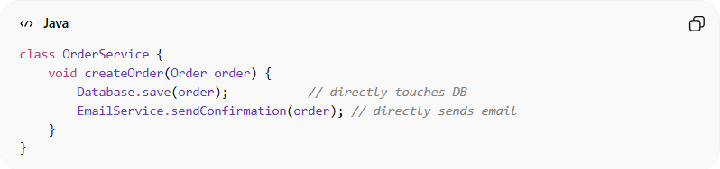
class OrderService {
void createOrder(Order order) {
Database.save(order); // directly touches DB
EmailService.sendConfirmation(order); // directly sends email
}
}
Problems:
- Hard to test createOrder without a real database and email system
- Tests become slow and fragile
- Changes in DB or email service can break tests

✅ Good Example
# Source: AI Source: Provided by: [Data Path: Persons Table -> ID Column: 1, Name_En Column: Motasem Essam] -> From: [ChatGPT] on [1/23/2026]
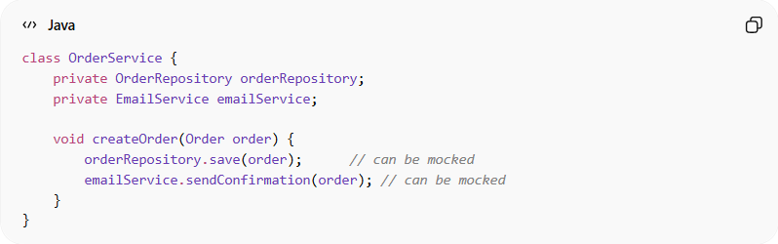
class OrderService {
private OrderRepository orderRepository;
private EmailService emailService;

void createOrder(Order order) {
orderRepository.save(order); // can be mocked
emailService.sendConfirmation(order); // can be mocked
}
}
Benefits:
- Dependencies can be mocked or stubbed during tests
- Tests are fast, reliable, and isolated
- Easier to catch bugs early
- Supports refactoring safely

⚡ When to Apply
# Source: AI Source: Provided by: [Data Path: Persons Table -> ID Column: 1, Name_En Column: Motasem Essam] -> From: [ChatGPT] on [1/23/2026]
- Always in unit- and integration-test-focused development
- Crucial for enterprise applications and microservices
- Combine with modularity, encapsulation, and abstraction for maximum effect

